**Voicetotext Summary report**

Step 1: Select Get Data and provide Azure Data Storage

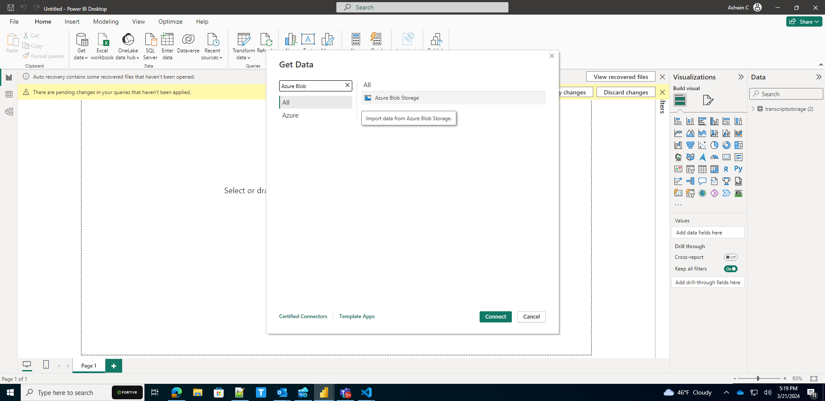

## Step 2 : provide account name as voicetotextstorage

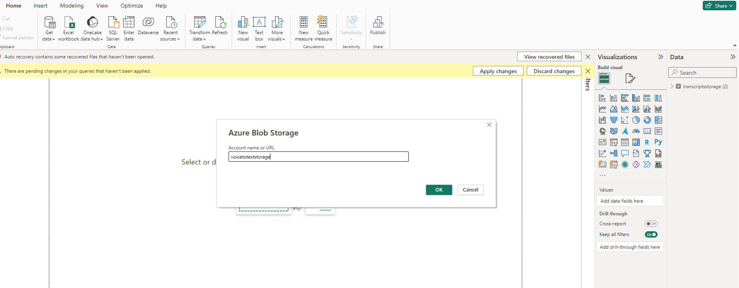

Step 3 : select **transcriptstorage and** load data

